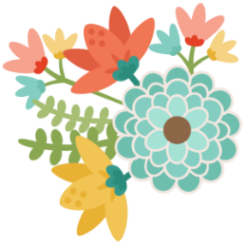these are a few of my
FAVORITE THINGS

Name:___Caitlin Reid_______________________

Monogram:___CNR___________________________

Birthday:______April 14th______________________
Favorite Drink:____Dr. Pepper__________________

Favorite Flower:____Lily_____________________

Favorite candy or treat:_____Anything chocolate____
Favorite salty snack:____Cheezits______________________

Any dietary restrictions:________NO____________

Favorite places to eat:__Chickfila, Sonic and Newk’s_

Favorite places to shop:____Target and Amazon_____

How do you relax:_watch tv and read books_______

Hobbies:____crafting and scrapbooking__________

