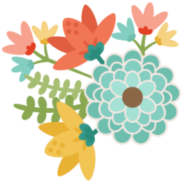these are a few of my
FAVORITE THINGS

Name: Lauren Smith

Monogram:LSA
Birthday: August 1
Favorite Drink: Sprite, Caramel Frappuccino, and Cherry Sprite
Favorite Flower: Red roses
Favorite candy or treat: Jolly rancher chews or hershey’s cookies ‘n’ creme
Favorite salty snack: popcorn or trail mix
Any dietary restrictions: N/A
Favorite places to eat: Longhorn Steakhouse, Chic fil A
Favorite places to shop: Target, TJ maxx, Marshalls
How do you relax: manicure, pedicure, and movies
Hobbies: shopping, exercising, crafting

